Atomic Structure

Andrew Seltzman, gtg135q
PHYS 4321-A
T/Th 2:35-5:55
Spring

2/27/2005

Georgia Institute of Technology
College of Sciences
School of Physics
Abstract

The Frank-Hertz experiment allows observation of energy level quantization in Hg and He electron shells leading to the confirmation of discrete levels in energy emission and absorption. The position of discrete absorption levels were observed as the sudden decrease in electron beam current as electron energy is lost during impact excitation of Hg atoms.
Observations of mercury energy absorption were used to quantify the first excitation level to be 4.81eV, within 1.03% of the theoretically determined value. Energy quantization was analyzed to provide a basis of discrete energy levels present in electron shells, leading to the result of discrete spectral line generation during energy shifts.

Introduction

The Frank-Hertz experiment provides direct evidence of energy level quantization in electron orbitals by providing direct evidence of discrete states in which energy can be absorbed or emitted by electron orbitals. These discrete energy levels can be observed by directing an electron beam into a chamber filled with a rarified gas of mercury or helium atoms. Electrons are sourced by a thermionic cathode, and accelerated by a variable potential in a Frank-Hertz tube (Figure I1). When a negatively biased electron collector, or positively in the case of helium, is positioned such that the electron beam is collects on its surface, the beam current detected at the plate surface is inversely proportional to the energy lost due to excitation of the mercury valence electrons.
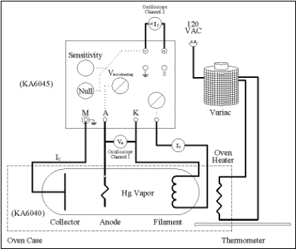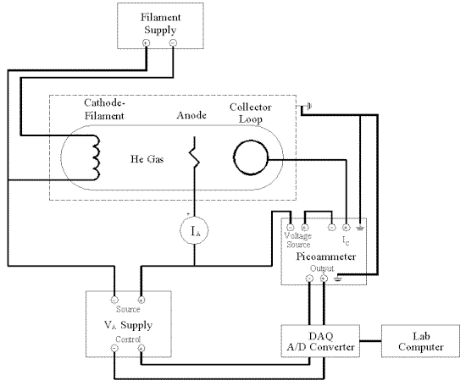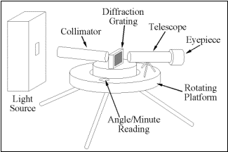
Figure I1. Frank-Hertz Hg tube, He tube, and Spectroscope (Courtesy of the Department of Physics, Georgia Institute of Technology).
Due to quantization of energy levels, the electron orbitals in an atom can only assume a discrete set of energy levels, thereby requiring a minimum energy transfer for an excitation to occur. As acceleration energy is increased the electron beams kinetic energy also increases, as well as the beam current due to the increased potential extracting electrons from the thermionic filament. This increase in energy, however allows for energy to be transferred to the Hg valence orbitals by impact excitation. This loss of energy prevents electrons from reaching the collector plate, thereby decreasing detected beam current.
Emitted beam current will increase linearly with applied acceleration potential; however detected beam current will only increase until the accelerating voltage reaches the minimum energy necessary required to excite the 6s valence shell of the Hg atom. At this point the highest energy electrons excite the 6s valence shell electrons into 6p electron shell (Figure 1C, Appendix C) by impact excitation, thereby loosing energy and decreasing collector current.
A similar setup is used to determine the helium ionization and excitation energy levels. In the helium Frank-Hertz tube, a positively biased collector ring is used to attract and collect scattered electrons. As electrons loose energy to the He valence shells bi impact excitation or ionization, they are scattered and are attracted to the positively biased collector loop, providing a direct relation between an increase in recorded collector current and He excitation levels.
Further evidence of energy quantization can be observed in the spectral output of a gas discharge tube filled with Na of He. As energy transitions occur between discrete energy levels, a discrete spectrum is generated for any given element. An observed spectral emission can be collimated with a slit and diffracted through a grating on a spectroscope, allowing measurement of wavelength as a function of diffraction angle. The observation of a discrete spectrum directly infers the presence of discrete energy transitions, and allows computation of electron shell structure.

Procedures

Mercury energy quantization levels are determined using a Frank-Hertz Klinger KA6040 mercury gas tube in conjunction with a LabView data acquisition system. The Frank-Hertz tube was heated to 200 C in a resistive oven to promote vaporization of the liquid mercury within the tube, yielding a higher gas pressure and reducing the mean free path thereby increasing the probability of an electron-Hg collision occurring. Filament and acceleration voltage were controlled by Agilent Technologies variable power supplies, and beam current was monitored on an Agilent Technologies picoammeter.
Prior to data acquisition, the picoammeter was zeroed, and the experiment voltage parameters were set in the Lab View acquisition program. The collector plate was biased at a negative voltage to promote electrostatic deflection of the scattered electrons with energy below the selected cutoff. The electron filament was set at 0.25A of current and provided free electrons for acceleration via thermionic emission. The accelerating voltage was swept from 0 to 60 volts potential difference and collector current was acquired in 0.05 volt increments at 10 increments per second. Collector bias potential was varied between -0.5 and -3 volts until the resulting positions of the observed peaks occurred in a liner distribution at -2 volts. Electron energy at the detected current peaks was determined and the difference between each successive energy state and the previously acquired value was calculated and averaged, yielding the excitation energy of the 6s shell valence electrons.
A similar procedure was implemented to determine the excitation and ionization potentials of helium in a similar apparatus controlled by LabView. In this case, an electron beam was projected into a sphere containing a rarified helium environment and current due to scattered electrons was detected. The collector plate was biased at a positive voltage to promote electrostatic attraction of electrons scattered by collision with helium atoms. The electron filament was set at 1.3A of current and provided free electrons for acceleration via thermionic emission. The accelerating voltage was swept from 0 to 50 volts potential difference and collector current was acquired in 0.05 volt increments at 10 increments per second. Collector bias potential was varied between 0.5 and 3 volts until the resulting collector current obtained a minimum of noise and generated a distinct peak distribution at 1.5 volts. Local minima in the resulting data indicate loss in electron energy due to inelastic collisions with helium atoms, generating excitation and ionization of the helium valence electrons.
Further analysis of Sodium and Helium atomic emission spectra was preformed using a spectroscope to observe the emission bands generated by Na and He arc lamps. Spectroscope eyepiece was aligned until the reticule was in focused and no parallax was present. The columniation slit was adjusted to produce the finest visible line to improve measurement accuracy. The Na spectrum was utilized to calibrate the spectroscope using a known emission wavelength. The grating was first aligned to within several minuets of arc from perpendicular to the collimated light beam. This was implemented by adjusting the grating until the left and right diffracted spectral lines were positioned within several minuets of each other. The grating separation was computed using the known wavelength of the Na yellow second order line (Figure 1B, Appendix B). Spectral lines were then recorded for the left and right diffracted fringes on both He and Na spectrums.

Results

Data acquired from the mercury Frank-Hertz tube showed a linear relation between the locations of current peaks with respect to accelerating voltage (Figure 1R). Peak values were selected and tabulated (Table A1, Appendix A). Electron energy at the detected current peaks difference between each successive energy state and the previously acquired value was calculated and averaged, allowing calculation of quantified excitation states of Hg.

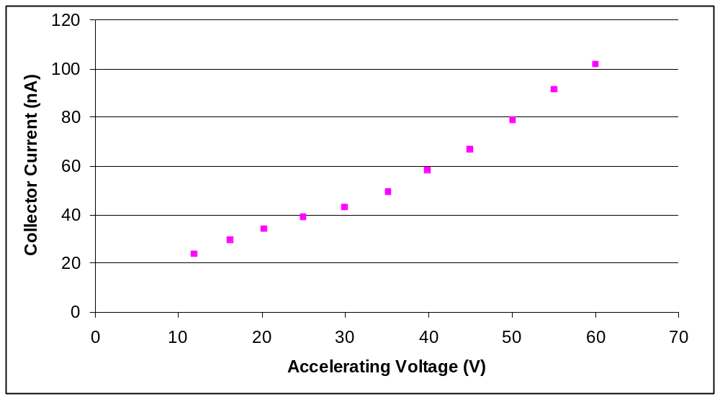

Figure 1R. Collector current in an Hg tube as a function of accelerating voltage with a collector bias of -2v at 200 C.
Similar data was obtained for the helium Frank-Hertz tube (Figure 2R). Minima in the current plot locate energy levels where inelastic scattering, excitation, or ionization occur.

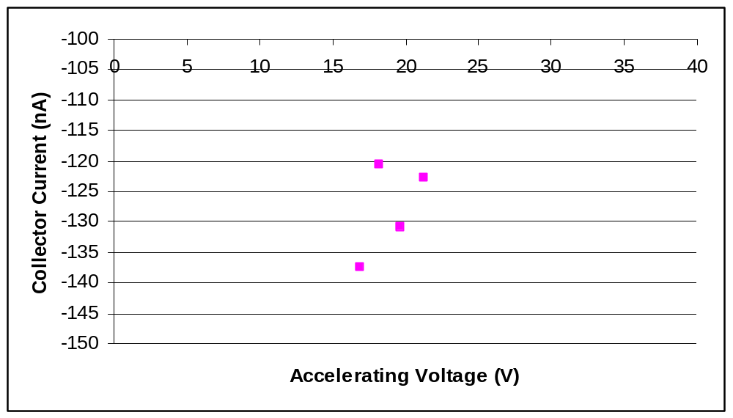
Figure 2R. Collector current in an He tube as a function of accelerating voltage with a collector bias of 1.5v at 25 C.

First and second order spectral data for the Na doublet was obtained with a spectroscope (Figure 3R) and tabulated (Table A2, Appendix A). Separation of the Na doublet was interpolated from photographic data (Figure 2B) and used to calculate energy separation (Figure 3B) due to the spin orbit effect.

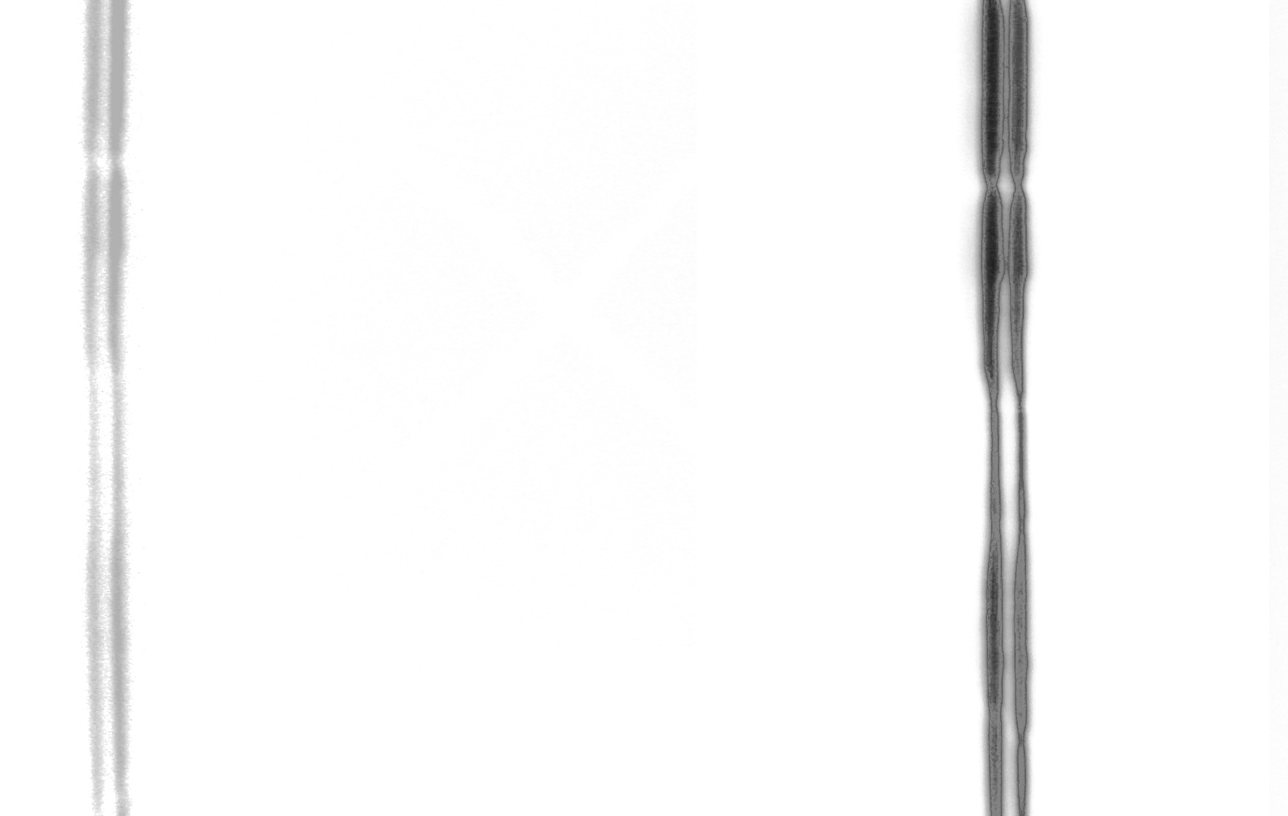
Figure 3R. Na second order right spectral line doublet GGYY.

Spectral data for the He doublet was obtained with a spectroscope (Figure 4R) and tabulated (Table A4, Appendix A).

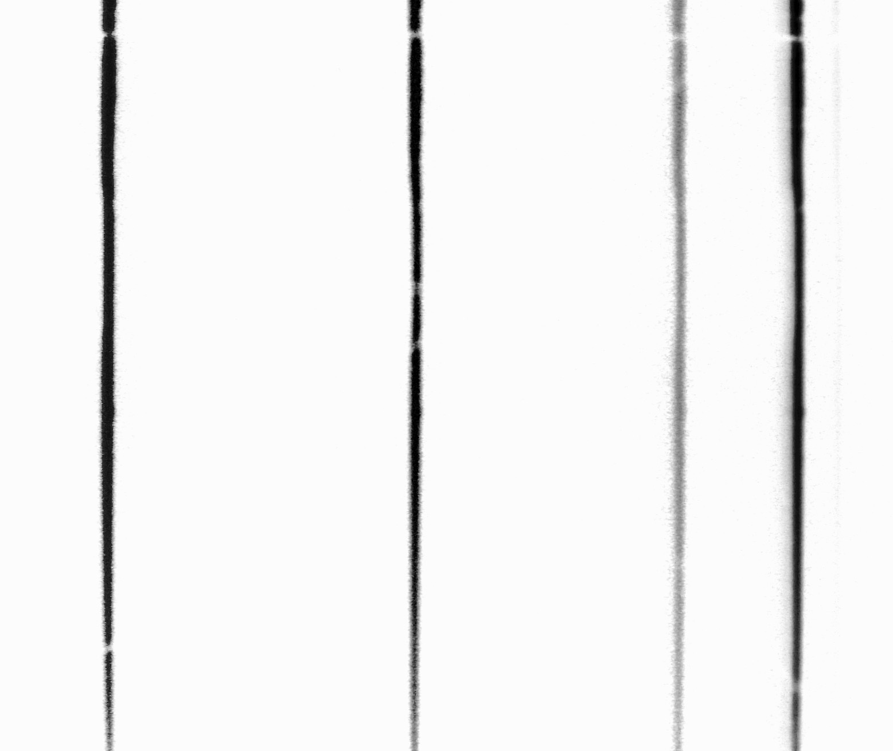
Figure 4R. He first order right spectral lines PPBGGG.

Discussion

Mercury excitation levels were acquired by directing a beam of electrons through a rarified mercury gas. Emitted beam current will increase linearly with applied acceleration potential; however detected beam current will only increase until the accelerating voltage reaches the minimum energy necessary required to excite the 6s valence shell of the Hg atom, thereby decreasing detected beam current by scattering. As acceleration energy increases, the atomic cross section of the Hg, electron collision becomes greater, increasing the probability of a collision resulting in energy transfer.
This further decreases detected beam current until the acceleration potential is increased to the point where the electrons have sufficient residual energy to reach the collector plate, and the current increases until the imparted acceleration energy is sufficient to produce two collisions where impact excitation occurs. At this point the cycle repeats with a continuous upward trend due to the higher beam current at increased acceleration potentials.
By computation of the difference in peak values obtained with the Frank-Hertz mercury tube, the primary excitation level of electrons in the 6s valence shell to the 6p electron shell was determined to be 4.81eV, within 1.03% of the theoretically determined 4.86eV energy requirement (Table A1, Appendix A).
A similar effect was observed while determining the helium excitation and ionization levels. Local minima (Table A1, Appendix A) in the plot of collector current as a function of acceleration voltage indicate where helium ionization levels occur. The 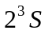 energy level was observed as a local minimum at 19.65eV, close to the 19.8eV level required for this transition. Multiple excitation states were observed at lower energies, but could not be quantified due to instrumentational effects.
A sharp increase in collector current was observed as electron beam energy became sufficient to allow impact ionization of the helium nuclei, generating an increase in free electrons. Ionization energy was determined to be 21.25eV, within 13.6% of the theoretical 24.6eV ionization potential.
Spectroscopic analysis of helium and sodium spectrums confirmed previous assumptions of discrete energy transitions. Both Na and He spectral lines were discrete, indicating energy transitions between electron shells emit only discrete energy quanta.
It was noted that the given spectroscope produced brighter fringes for the right diffracted spectral lines, therefore data collected for analysis was obtained with greater depth on the right diffracted spectrum. Data was collected for both helium and sodium spectra and tabulated in Appendix A.
Photographic data was processed to obtain a high accuracy evaluation of the right second order doublet separation, allowing the calculation of the energy difference due to the spin orbit effect in sodium. A digital picture was processed in Photoshop to obtain a accurate measure of the sodium doublet separation. The image was rotated until the spectral lines were positioned vertically, and a high magnitude vertical blur was generated, averaging the y components into a discrete set of Y invariant lines, but maintaining their X position data. A binary threshold filter was implemented as a peak detector isolating the vertical component of greatest luminosity, thereby locating the center of each spectral line to a single pixel width band (Figure 2B, Appendix B) and eliminating any parallax effects.
A ratio was constructed between the separation of pixels between the green spectral line and the second order right sodium doublet, and the pixel separation between the doublet lines. This ratio was multiplied by the recoded angle between the green line and sodium doublet in degrees, to determine the separation between the sodium doublet line components in degrees.
Theoretical calculation of the energy shift due to spin orbit interaction ΔE = μ_{B}gB = 2.1E-3 eV (Hyperphysics) was confirmed within 23.6% by an experimental result 1.603E-3 eV calculated (Figure 3B, Appendix B) from the photographic interpolation. This doublet is generated by transitions between the 3p and 3s electron shells with antiparallel electron spins.

Conclusion
Observations of mercury energy absorption were used to quantify the first excitation level to be 4.81eV, within 1.03% of the theoretically determined value. It was further determined that the ionization level of helium is 21.25eV, within 13.6% of the theoretically calculated value. Photographic interpolation was used in conjunction with a spectroscope to increase instrumentation resolution and accuracy, allowing a direct calculation of the spin orbit effect energy shift present in the sodium doublet. The energy shift was calculated to be 1.603E-3 eV, within 23.6% of the theoretically determined value.
Energy quantization was analyzed to provide a basis of discrete energy levels present in electron shells, leading to the result of discrete spectral line generation during energy shifts.
References

“Frank-Hertz Experiment.” Georgia Tech Advanced Physics Labs.
February 2005. Georgia Institute of Technology. September 1, 2002
< http://www.physics.gatech.edu/advancedlab/>

“Sodium Doublet.” Hyperphysics.
February 2005. Georgia State University.
< http://hyperphysics.phy-astr.gsu.edu/hbase/quantum/sodzee.html>

“Discrete Electron States in an Atom: The Franck-Hertz Experiment”
February 2005. Purdue University.
<http://www.physics.purdue.edu/~sergei/classes/phys342l/franckhertz.doc>
Appendix A: Experimental Data

Table A1. Hg Peak Location and Excitation Level Spacing, He Local Minima

 | Hg |  |  |  | He
 | V | nA | eV(n+1)-eV(n) |  | eV | nA
 | 11.95 | 23.621 |  |  | 16.85 | -137.421
 | 16.2 | 29.358 | 4.25 |  | 18.2 | -120.499
 | 20.3 | 33.997 | 4.1 |  | 19.65 | -130.783
 | 25 | 39.093 | 4.7 |  | 21.25 | -122.772
 | 30 | 42.847 | 5
 | 35.2 | 49.377 | 5.2
 | 39.9 | 58.041 | 4.7
 | 44.95 | 66.803 | 5.05
 | 50.05 | 78.857 | 5.1
 | 55.1 | 91.492 | 5.05
 | 60.05 | 101.837 | 4.95
Average |  |  | 4.81

Table A2. Na Spectral Data

Na Spectrum Lines
 | RRYYGGRYYGTTBB<0>BBBTTGYYRGGYYRR
 | Left Scale |  | Right Scale
Zero Line | 26.9167 |  | 206.933
 | 26.9167 |  | 206.95
Average | 26.9167 |  | 206.942
Left Spectral Lines
 | Left |  |  |  |  | 2nd Order |  |  |  |  | Right
 | R | R | Y | Y | G | G | R | Y | Y | G | Zero
 | ND | ND | 72.1667 | 72.0833 | 70.15 | ND | 48.7 | 47.75 | 47.7167 | 46.9833
 | ND | ND | 72.15 | 72.0667 | 70.1667 | ND | 48.6833 | 47.75 | 47.7333 | 47
Average |  |  | 72.1583 | 72.075 | 70.1583 |  | 48.6917 | 47.75 | 47.725 | 46.9917 | 26.9167
Delta Zero |  |  | 45.2417 | 45.1583 | 43.2417 |  | 21.775 | 20.8333 | 20.8083 | 20.075 | 0
Delta Separation (Above, Right) |  |  | 0.08333 | 1.91667 |  |  | 0.94167 | 0.025 | 0.73333
Right Spectral Lines
 | Left |  |  |  |  | 2nd Order |  |  |  |  | Right
 | Zero | G | Y | Y | R | G | G | Y | Y | R | R
 |  | 186.783 | 186.083 | 186.017 | 185.05 | ND | 163.433 | 161.467 | 161.417 | ND | ND
 |  | 186.683 | 186.067 | 186.017 | 185.067 | ND | 163.417 | 161.45 | 161.417 | ND | ND
Average | 206.942 | 186.733 | 186.075 | 186.017 | 185.058 |  | 163.425 | 161.458 | 161.417
Delta Zero | 0 | 20.2083 | 20.8667 | 20.925 | 21.8833 |  | 43.5167 | 45.4833 | 45.525
Delta Separation (Above, Left) |  |  | 0.65833 | 0.05833 | 0.95833 |  |  | 1.96667 | 0.04167

Table A3. Second Order Na Doublet Average Angle

 |  | Left | Right
Outer Doublet |  | 45.24167 | 45.525
Inner Doublet |  | 45.15833 | 45.48333
Average |  | 45.2 | 45.50417

Table A4. He Spectral Data

He Spectrum Lines
 | RRYGGGBP<0>PPBGGGYRRPBGGG
 | Left Scale |  | Right Scale
Zero Line | 26.9333 |  | 206.95
 | 26.9167 |  | 206.967
Average | 26.925 |  | 206.958
Left Spectral Lines
 | Left |  |  |  |  |  |  |  | Right
 | R | R | Y | G | G | G | B | P | Zero
 | ND | ND | 47.6667 | 44.6333 | 44.5333 | 44.1833 | 43.45 | 42.5833
 | ND | ND | 47.6667 | 44.6 | 44.5333 | 44.1833 | 43.4333 | 42.5833
Average |  |  | 47.6667 | 44.6167 | 44.5333 | 44.1833 | 43.4417 | 42.5833 | 26.925
Delta Zero |  |  | 20.7417 | 17.6917 | 17.6083 | 17.2583 | 16.5167 | 15.6583 | 0
Delta Separation (Above, Right) |  |  | 3.05 | 0.08333 | 0.35 | 0.74167 | 0.85833
Right Spectral Lines
 | Left
 | Zero | P | P | B | G | G | G | Y | R | R
 |  | 191.55 | 191.267 | 190.4 | 189.65 | 189.3 | 189.183 | 186.1 | 183.117 | 181.617
 |  | 191.567 | 191.25 | 190.417 | 189.65 | 189.3 | 189.167 | 186.117 | 183.133 | 181.6
Average | 206.958 | 191.558 | 191.258 | 190.408 | 189.65 | 189.3 | 189.175 | 186.108 | 183.125 | 181.608
Delta Zero (deg) | 0 | 15.4 | 15.7 | 16.55 | 17.3083 | 17.6583 | 17.7833 | 20.85 | 23.8333 | 25.35
Wavelength (m) |  | 1.6E-06 | 1.6E-06 | 1.6E-06 | 1.6E-06 | 1.6E-06 | 1.6E-06 | 1.5E-06 | 1.5E-06 | 1.5E-06
Delta Separation (Above, Left) |  |  | 0.3 | 0.85 | 0.75833 | 0.35 | 0.125 | 3.06667 | 2.98333 | 1.51667
 |  |  | 2nd Order |  |  |  | Right
 |  |  | P | B | G | G | G
 |  |  | 174.2 | 172.183 | 170.4 | 169.6 | 169.283
 |  |  | 174.217 | 172.167 | 170.417 | 169.583 | ND
Average |  |  | 174.208 | 172.175 | 170.408 | 169.592 | 169.283
Delta Zero (deg) |  |  | 32.75 | 34.7833 | 36.55 | 37.3667 | 37.675
Wavelength (m) |  |  | 1.4E-06 | 1.4E-06 | 1.3E-06 | 1.3E-06 | 1.3E-06
Delta Separation (Above, Left) |  |  | 7.4 | 2.03333 | 1.76667 | 0.81667 | 0.30833

Appendix B: Computation

Second order sodium doublet wavelength: 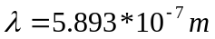
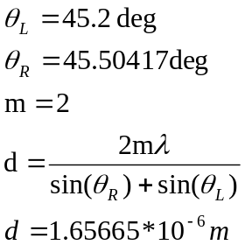
Figure 1B. Grating width computation.


Figure 2B. Sodium doublet processed image.

Second Order Right Na doublet Photographic Interpolation
 |  |  |  | Pixels | Degrees
Inner Right Na Doublet |  |  |  | 1460 | 161.4583
Outer Right Na Doublet |  |  |  | 1497 | 161.4167
Difference (Na Doublet) |  |  |  | 37 | 0.041667
Outer Green Spectral Line |  |  |  | 275 | 163.425
Difference (Inner Na, Outer Green) |  |  |  | 1185 | 1.966667
Photographically Interpolated Separation |  |  |  |  | 0.061406

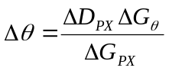 Where is doublet 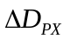 is doublet separation in pixels, and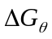, 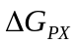 are the separation between the second order outer green line and inner Na doublet line in degrees and pixels, respectively.

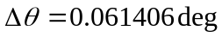

Figure 3B. Second Order Right Na doublet Photographic Interpolation.

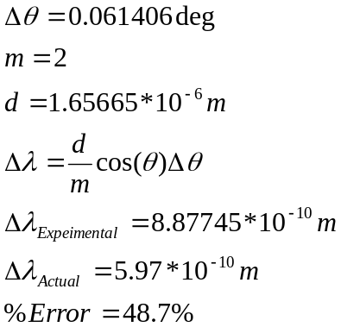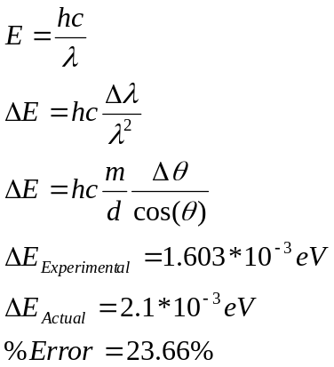

Figure 4B. Sodium doublet spin orbit comparison.
Appendix C: Supplemental Information

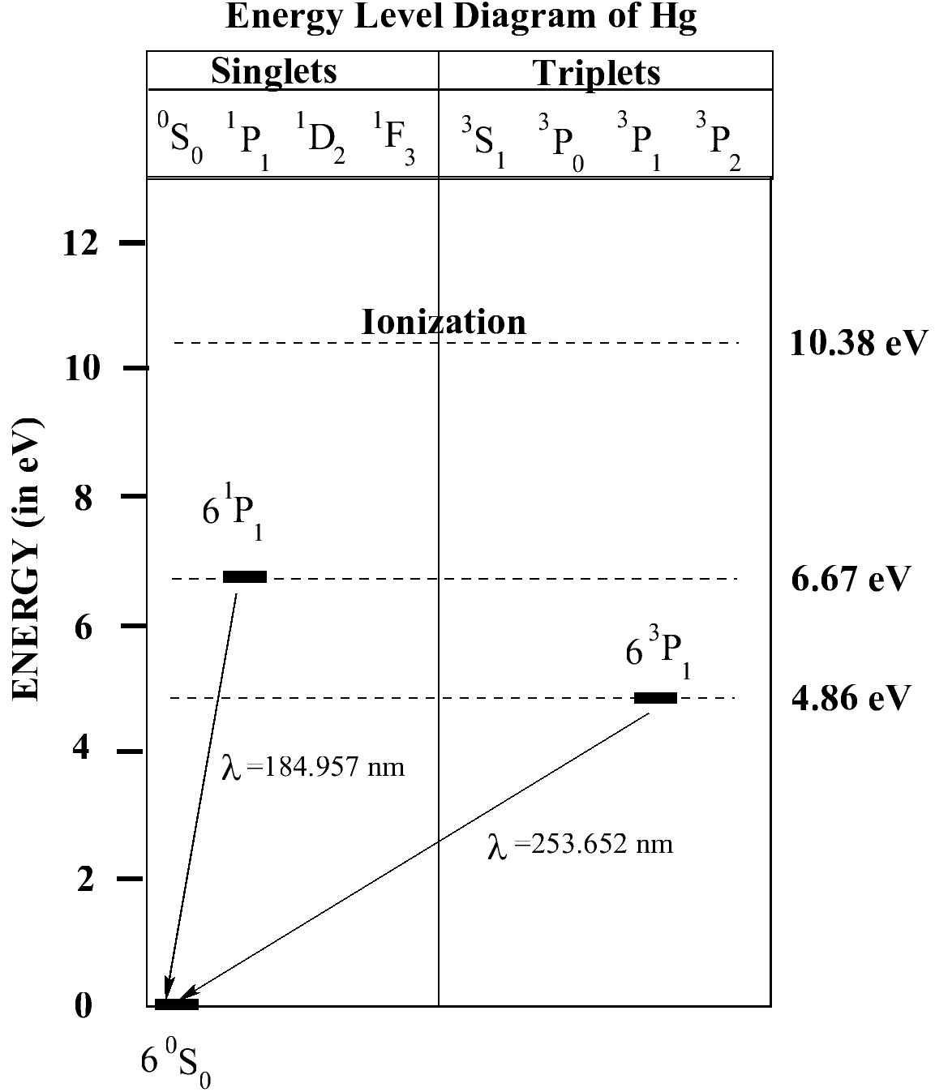

Figure 1C. Excitation of 6s shell valence electrons in Hg. (Courtesy of the Department of Physics, Purdue University)

